Replace Dubai’s Vibrant with UAE’s Vibrant.

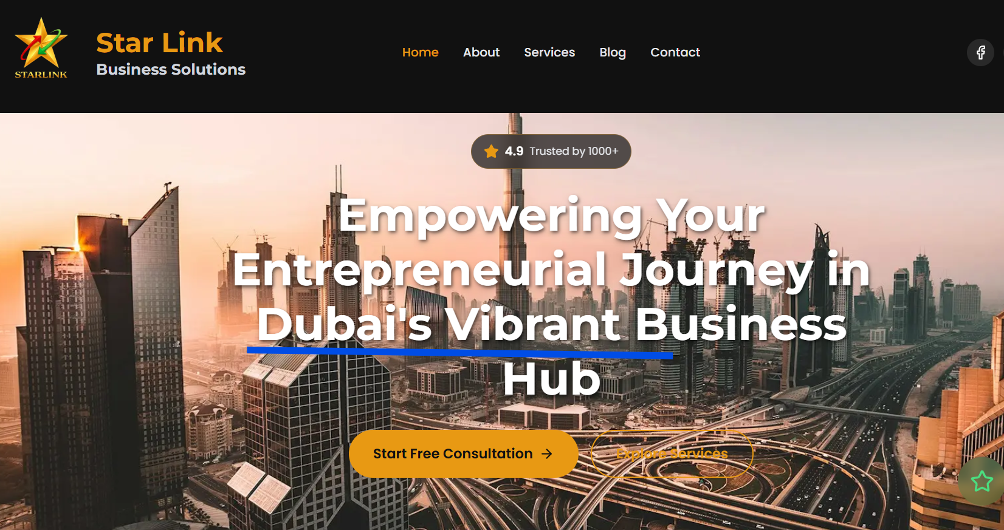

Landing page is not popping up .

Enlarge letters of “Star Link” bit more :

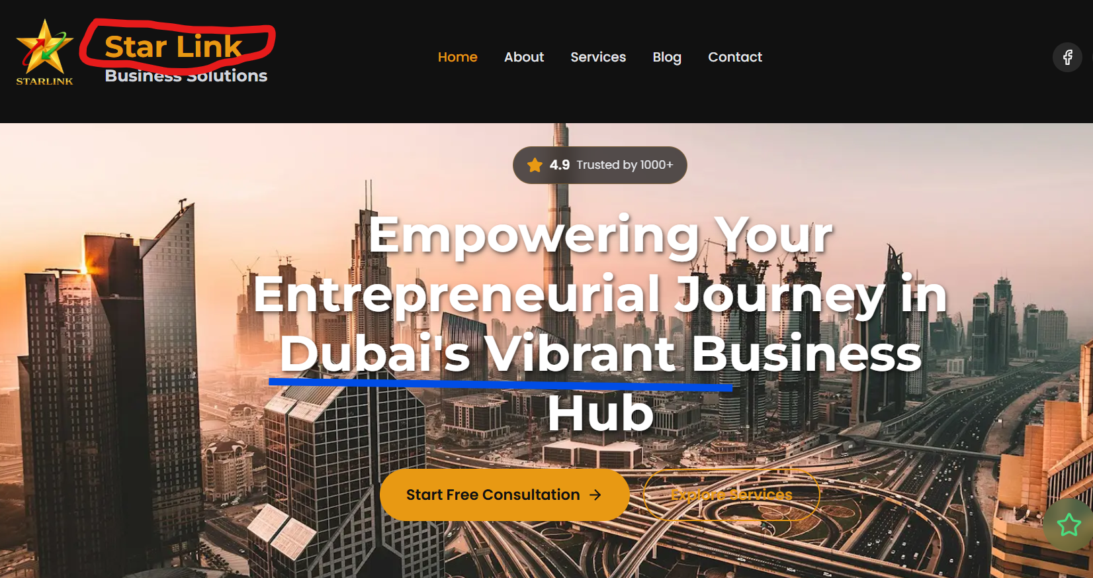

The Social Media is not linked ,as per our understanding it will be done when website is hosted online,right?



